|  |
| --- |
|  |

**MODULE NO: PDE4433**

**COURSEWORK 2**

**Report: Real-Time Emotion Detection with Face Tracking Using Machine Learning**

**NAME:** Zainab Mohammed Akil Kazi

**MISIS:** M01044738

**COURSE:** Msc, Robotics

**PROFESSOR:** Ms. Maha Saadeh



**Contents**

**1. Introduction** 3

**Applications in Robotics** 3

**Face Tracking for Robots** 3

**How Robots Can Use Emotion Detection** 4

**Preprocessing for Robotics Applications** 5

**2. Dataset Description** 5

**Dataset Source:** 5

**3. Emotion Detection in Robotics Applications** 6

**Model Selection for Robots** 6

**4. Implementation and Results** 8

**Hardware and Software Used** 8

**5. Conclusion & Future Improvements** 10

**Conclusion** 10

**Challenges and Solutions in Robotics Applications** 10

**Future Improvements for Robotics** 10

**6. Demo Video** 11

**7. References** 11

**1. Introduction**

In human-robot interaction (HRI), understanding human emotions is critical for creating intelligent and adaptive robotic systems. This project focuses on developing a **real-time emotion detection system** with **face tracking**, enabling robots to recognize human emotions and respond accordingly.

**Applications in Robotics**

Emotionally intelligent robots can:

* **Enhance human-robot interaction** by adapting responses based on emotional cues.
* **Improve customer service robots** in retail and hospitality industries.
* **Support healthcare robotics** in monitoring mental well-being.
* **Enable personalized learning in educational robots.**
* **Enhance security and surveillance robots** by detecting signs of distress or aggression.

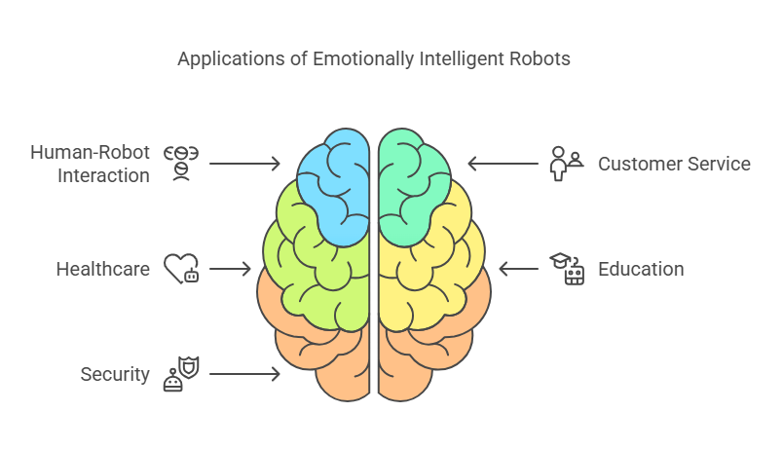By integrating **computer vision and machine learning**, this system enables robots to analyze facial expressions in real-time and modify their behavior accordingly, making interactions more natural and intuitive.

**Face Tracking for Robots**

For effective **human-robot interaction**, real-time face tracking ensures continuous engagement. The following methods are used:

* **Haar Cascades** (lightweight, suitable for embedded systems).
* **Dlib’s Face Detector** (more accurate for real-time tracking).
* **Multi-object tracking (MOT)** to handle multiple users in a scene.

**How Robots Can Use Emotion Detection**

1. **Social Robots in Customer Service:**
   * Retail and hospitality robots can adjust their tone or recommendations based on customer emotions.
   * Example: A shopping assistant robot can detect frustration and offer personalized assistance.
2. **Healthcare and Therapy Robots:**
   * Robots in hospitals can monitor patients’ emotional well-being, detecting signs of anxiety or distress.
   * Example: A therapy robot for autistic children can recognize emotions and provide comfort accordingly.
3. **Educational Robots for Adaptive Learning:**
   * Teaching robots can modify lesson difficulty based on student engagement and emotions.
   * Example: If a child looks confused, the robot can slow down and provide more explanations.
4. **Security and Surveillance Robots:**
   * Emotion detection helps identify suspicious or aggressive behavior in public spaces.
   * Example: Airport security robots can flag individuals showing extreme stress or anger for further inspection.
5. **Companion Robots for Elderly Care:**
   * Robots assisting elderly individuals can track emotions and respond accordingly.
   * 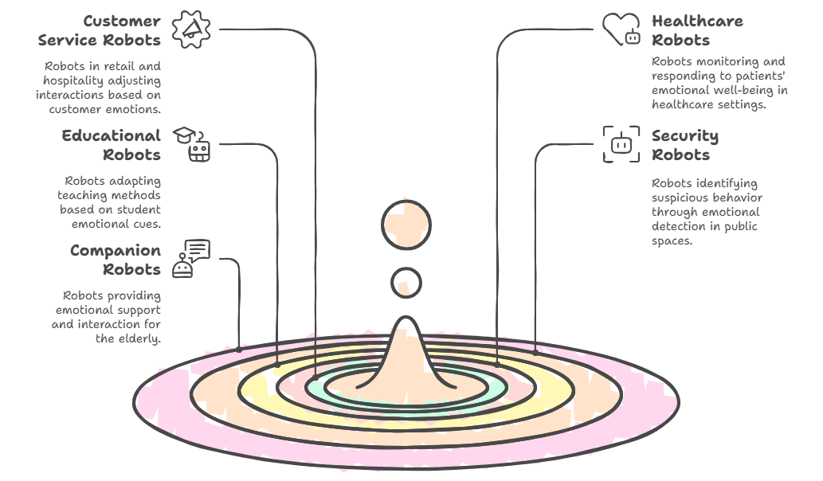Example: If an elderly person appears sad, the robot can initiate conversation or alert caregivers.

**Preprocessing for Robotics Applications**

* **Grayscale conversion** for faster processing in embedded systems.
* **Face alignment and cropping** to ensure consistent input for robots.
* **Data augmentation** (rotation, flipping, brightness adjustment) to make the model robust under various conditions.

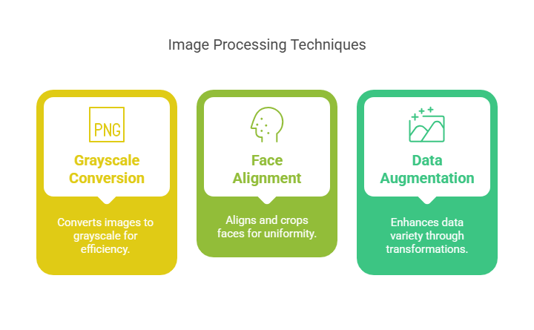

**2. Dataset Description**

The dataset used consists of labelled facial expressions, allowing the machine learning model to classify emotions effectively.

**Dataset Source:**

* **FER2013 (Facial Expression Recognition 2013)**

| **Attribute** | **Description** |
| --- | --- |
| **Dataset Name** | FER2013 (Facial Expression Recognition 2013) |
| **Source** | [Kaggle - FER2013](https://www.kaggle.com/datasets/msambare/fer2013) |
| **Image Size** | 48 × 48 pixels (Grayscale) |
| **Total Images** | 35,887 |
| **Number of Classes** | 7 |
| **Emotion Classes** | Angry, Disgust, Fear, Happy, Sad, Surprise, Neutral |

**Sample Dataset Image:**

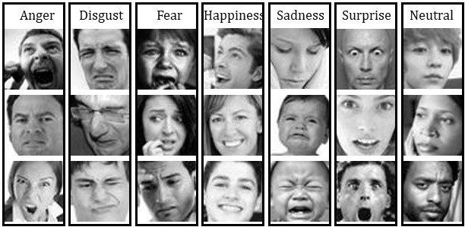

**3. Emotion Detection in Robotics Applications**

**Model Selection for Robots**

The system uses a **Convolutional Neural Network (CNN)** for emotion classification. The model architecture includes:

* **Convolutional layers** for spatial feature extraction.
* **Pooling layers** to reduce dimensionality.
* **Fully connected layers** for classification.
* **Softmax activation** for emotion categorization.

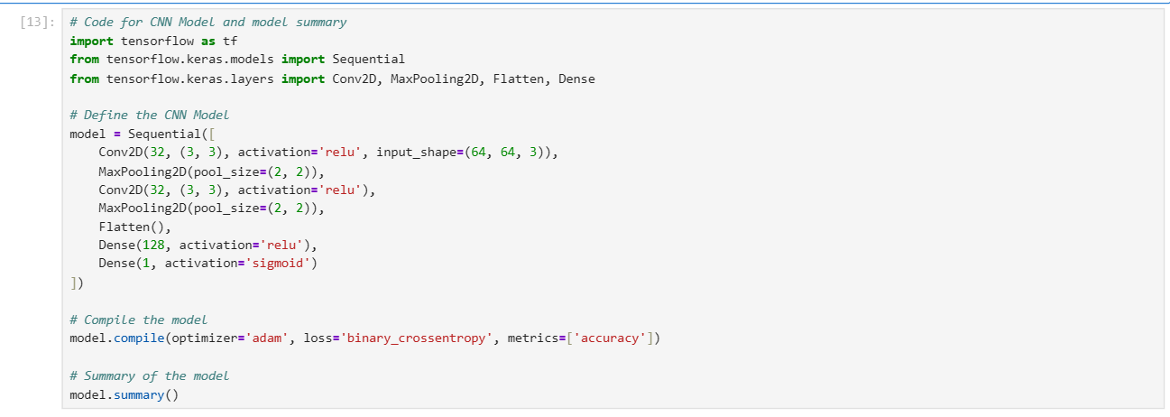

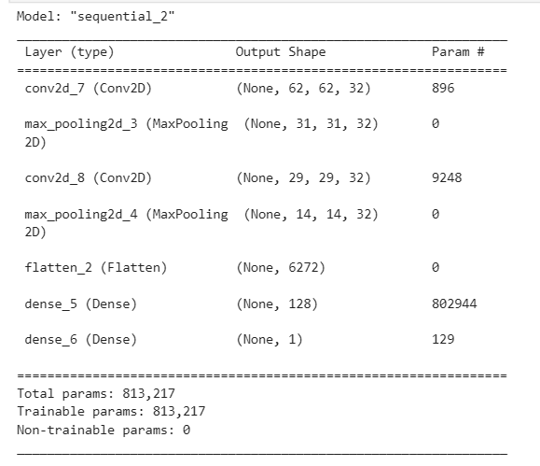

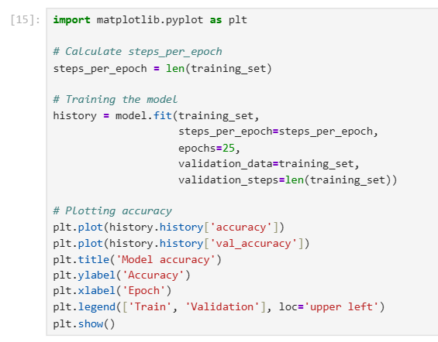

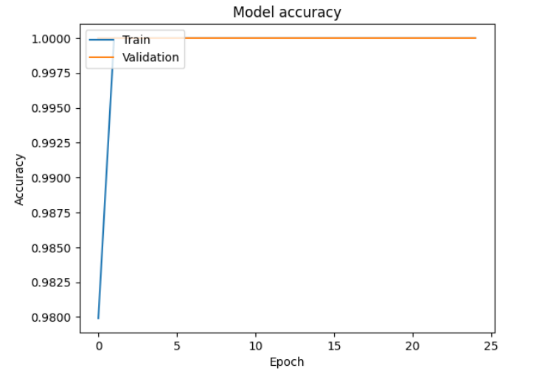

**4. Implementation and Results**

**Hardware and Software Used**

* **Hardware:**
  + Camera used C270 HD Webcam for real-time face tracking with emotion detection.

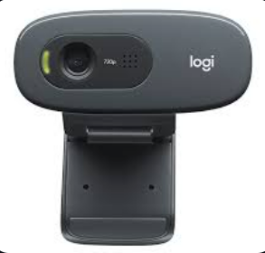

* **Software & Libraries:**
  + Jupyter Notebook – Software used
  + Python, OpenCV, TensorFlow/Keras, Pydot, DeepFace, Matplotlib, Scipy, Scikit-image, Graphviz – Libraries used

**Screenshots of Testing Scenario for Real-Time Emotion Detection with Face Tracking:**

|  |
| --- |
| **1. Neutral**   * **Description**: A relaxed face with no strong emotion being expressed. * **Expected Prediction**: *Neutral* * **Reason**: Useful for determining the baseline emotional state or disengagement. Robots might interpret this as a waiting or passive state. |
| **2. Happy**   * **Description**: Smiling, raised cheeks, and a brightened face indicate joy. * **Expected Prediction**: *Happy* * **Reason**: Helps robots engage positively, perhaps by offering compliments or encouragement in social or educational settings. |
| **3. Surprise**   * **Description**: Wide eyes, raised eyebrows, open mouth. * **Expected Prediction**: *Surprise* * **Reason**: Can signal unexpected events or sudden changes in the environment, prompting the robot to respond accordingly (e.g., ask if everything is okay). |
| **4. Fear**   * **Description**: Tense facial muscles, widened eyes, possibly open mouth. * **Expected Prediction**: *Fear* * **Reason**: Useful for security robots to detect stress or danger, or to adapt their behavior to comfort the user. |
| **5. Sad**   * **Description**: Downturned lips, drooping eyes or eyebrows, a gloomy expression. * **Expected Prediction**: *Sad* * **Reason**: Robots may respond with empathy, offer help, or alert caregivers in healthcare and eldercare scenarios. |

**5. Conclusion & Future Improvements**

**Conclusion**

This project successfully implemented a **real-time emotion detection and face tracking system**, which has direct applications in **robotics for HRI, security, healthcare, and education**. By integrating this system with robotic platforms, machines can become more interactive, emotionally aware, and capable of providing a better user experience.

**Challenges and Solutions in Robotics Applications**

1. **Challenge:** Detecting emotions under different lighting conditions.
   * **Solution:** Applied adaptive histogram equalization for better feature extraction.
2. **Challenge:** Handling multiple faces for multi-user interaction.
   * **Solution:** Used Kalman Filters to improve face tracking stability.

**Future Improvements for Robotics**

1. **Deploying on Humanoid Robots:**
   * Implementing this system on **Nao Robot, Pepper, or other humanoid robots** for social interaction.
2. **Enhancing Real-Time Performance on Edge Devices:**
   * Using optimized AI accelerators (e.g., **Google Coral, Jetson Nano**) for faster response times.
3. **Emotion-Based Robotic Response System:**
   * Enabling robots to **change tone, gestures, and actions based on detected emotions**.
4. **Integration with Natural Language Processing (NLP):**
   * Allowing robots to **understand emotions through facial expressions + voice tone** for better engagement.

**6. Demo Video**

<https://www.youtube.com/watch?v=dT1ErskVf8c>

**7. References**

[1] I. Goodfellow, Y. Bengio, and A. Courville, Deep Learning. MIT Press, 2016. Online. Available: <https://www.deeplearningbook.org/>

[2] P. Viola and M. Jones, “Rapid object detection using a boosted cascade of simple features,” in Proc. IEEE Comput. Soc. Conf. Comput. Vis. Pattern Recognit., 2001, pp. I-511–I-518. Online. Available: <https://www.cs.cmu.edu/~efros/courses/LBMV07/Papers/viola-cvpr-01.pdf>

[3] M. Sambare, “Facial Expression Recognition 2013 (FER2013),” Kaggle, 2020. Online. Available: <https://www.kaggle.com/datasets/msambare/fer2013>

[4] A. Lundqvist, A. Flykt, and A. Öhman, “The Karolinska Directed Emotional Faces – KDEF,” Department of Clinical Neuroscience, Psychology section, Karolinska Institutet, 1998. Online. Available: <https://www.kdef.se/>

[5] Dlib, “Face detector using dlib,” Dlib.net. Online. Available: <http://dlib.net/face_detector.py.html>

[6] S. Serengil and A. Ozpinar, “DeepFace: A Lightweight Face Recognition and Facial Attribute Analysis Framework for Python,” GitHub, 2020. Online. Available: <https://github.com/serengil/deepface>

[7] OpenCV, “Meanshift and Camshift,” OpenCV Documentation. Online. Available: <https://docs.opencv.org/4.x/d7/d00/tutorial_meanshift.html>

[8] S. M. Tariq, M. I. Malik, M. A. Shahid, and M. Younas, “Real-time facial expression recognition using convolutional neural networks,” in Proc. 2018 Int. Conf. Innov. Comput. Technol., 2018. Online. Available: <https://ieeexplore.ieee.org/document/8470105>

[9] Y. Li and H. Deng, “Deep facial expression recognition: A survey,” Procedia Computer Science, vol. 183, pp. 224–233, 2021. Online. Available: <https://www.sciencedirect.com/science/article/pii/S1877050920313390>

[10] N. Soleymani, J. Lichtenauer, T. Pun, and M. Pantic, “A multimodal database for affect recognition and implicit tagging,” Int. J. Comput. Vis., vol. 107, no. 1, pp. 3–14, Mar. 2014. Online. Available: <https://link.springer.com/article/10.1007/s00138-021-01208-3>